Wheel Chock Details
Sr.No | Product | Specification | Image | Qty | Unit Rate
1 | Two Sided Wheel Chock | L9.8 X W7.5 X H5.9 inches  Weight : 4.5 kg  Material : Rubber with metal eye bolt  Also availabel with Rope | 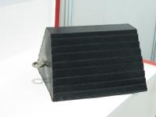 | 1 | Rs. 550
2 | L Rubber Wheel Chock with eye bolt | L9.4 X W6.5 X H7.6 inches  Weight : 3.5 kg  Material : Rubber With eye bolt. | 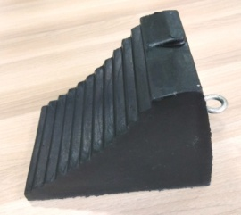 | 1 | Rs.550
3 | L Rubber Wheel Chock with rope | L9.5 X W7 X H6.5 inches  Weight : 5.5 kg  Material : Rubber with rope | 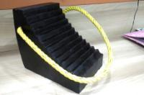 | 1 | Rs. 750
4 | Heavy Duty Laminated Wheel Chock | 8 X 8 X 8 inches  Weight : 6 kg  Material : Tyre laminates compress in gun metal | 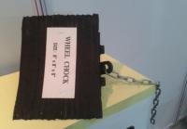 | 1 | Rs.1400
5 | RUBF Wheel Chock | L7.7 x W5.9 X H9.4 inches  Weight : 6 kg  Material : Rubber with metal eye bolt | 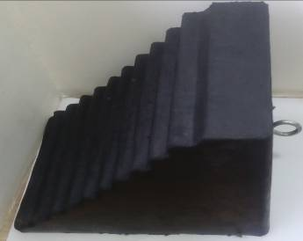 | 1 | Rs. 1100

Terms & Conditions
- GST 18% Extra.
- P & F Charges Rs.300/order.
- Delivery charges extra as per order.
- 100 % Payment in advance.
- Kindly raise PO for order confirmation.

